Install Lirc:

sudo apt-get install lirc

Edit **/etc/modules** and add the following (if you use another GPIO pin then change the lines):

lirc\_dev

lirc\_rpi gpio\_in\_pin=23 gpio\_out\_pin=22

Edit **/etc/lirc/hardware.conf** and change it to:

LIRCD\_ARGS=”–uinput”

LOAD\_MODULES=true

DRIVER=”default”

DEVICE=”/dev/lirc0″

MODULES=”lirc\_rpi”

LIRCD\_CONF=””

LIRCMD\_CONF=””

If you run an older 3.18 kernel change the **/boot/config.txt** file and add the following line:

dtoverlay=lirc-rpi,gpio\_in\_pin=23,gpio\_out\_pin=22

Reboot Raspberry Pi in order to apply changes.

Connect the IR Led. I used the following schema:

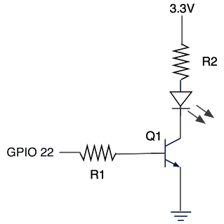

* Q1 = BC547 it’s a transistor used to give the IR led enough power.
* R1 = 220ohm
* R2 = you can skip this
* 940nm IR LED 40deg

After you have installed and configured Lirc for RaspberryPi, the first thing to check is if your TV is in Lirc Database. In my case I am able to control: My LG TV, Microlab Audio system

For starting TV and then MUTE I created a small script:

#!/bin/bash

/usr/bin/irsend SEND\_ONCE lg\_tv KEY\_POWER

sleep 10

/usr/bin/irsend SEND\_ONCE lg\_tv KEY\_MUTE

Then I created in [RController](http://rcontroller.duculete.com/" \t "_blank) a new command. This way when I get home, I can turn on TV from my phone, dim lights and set an ambient atmosphere to enjoy my movie.

I created a small script that runs via cron on my RaspberryPi and checks if current time is past 7 PM and if I am at home (it will search for my phone by ping). If it is past 7PM and I am arriving home, it  will turn on lights and TV.